VM set up and Deployment process
Perform Steps 1 to 4 in master and worker Nodes
Step1 sudo apt update
Step2 Kubernetes installation steps
- sudo apt install curl
- curl -s https://packages.cloud.google.com/apt/doc/apt-key.gpg | sudo apt-key add - && echo "deb http://apt.kubernetes.io/ kubernetes-xenial main" | sudo tee /etc/apt/sources.list.d/kubernetes.list && sudo apt-get update -q && sudo apt-get install -q kubelet=1.23.4-00 kubectl=1.23.4-00 kubeadm=1.23.4-00
- kubectl version
Step3: Disable Swap
Turn off swap.
● sudo sed -i '/ swap / s/^\(.*\)$/#\1/g' /etc/fstab
● sudo swapoff -a
Enable kernel modules and configure sysctl.
=> Enable kernel modules
● sudo modprobe overlay
● sudo modprobe br_netfilter
=> Add some settings to sysctl
● sudo vi /etc/sysctl.d/kubernetes.conf
Paste the below content in the conf file :
net.bridge.bridge-nf-call-ip6tables = 1
net.bridge.bridge-nf-call-iptables = 1
net.ipv4.ip_forward = 1
=> # Reload sysctl
● sudo sysctl --system
Step4: Install Docker runtime :
=> Add repo and Install packages
● sudo apt update
● sudo apt install -y curl gnupg2 software-properties-common apt-transport-https ca-certificates
● curl -fsSL https://download.docker.com/linux/ubuntu/gpg | sudo apt-key add -
● sudo add-apt-repository "deb [arch=amd64] https://download.docker.com/linux/ubuntu $(lsb_release -cs) stable"
● sudo apt update
● sudo apt install -y containerd.io docker-ce docker-ce-cli
=> Create required directories
● sudo mkdir -p /etc/systemd/system/docker.service.d
=> # Create daemon json config file
● sudo vi /etc/docker/daemon.json
Paste the below content in json file
{
"exec-opts": ["native.cgroupdriver=systemd"],
"log-driver": "json-file",
"log-opts": {
"max-size": "100m"
},
"storage-driver": "overlay2"
}
=> Start and Enable Services
● sudo systemctl daemon-reload
● sudo systemctl restart docker
● sudo systemctl enable docker
Step5: sudo apt install vim
Step6: Network Configuration Changes
Master Node :
● sudo vi /etc/hosts
Add the below highlighted lines in master node /etc/hosts
127.0.1.1 <master-node hostname>
Worker Nodes :
● sudo vi /etc/hosts
Add the below highlighted lines in both worker01 and worker02 /etc/hosts
<master-node IP> <master-node hostname>-master.com
<master-node IP> <master-node hostname>
Example
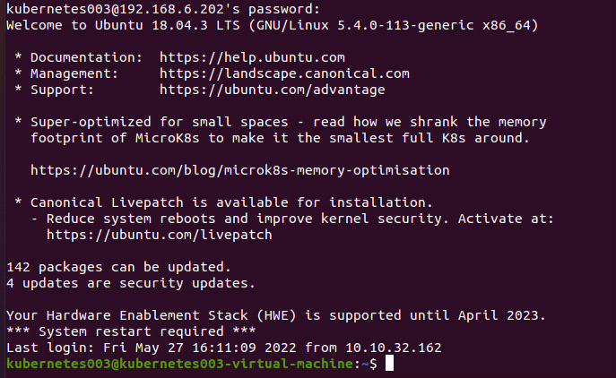
Note :
<master-node IP > : IP of Master Node example IP 192.168.6.202
<master-node hostname> : Hostname of Master Node example kubernetes-virtual -machine
Enable kubelet service on both master and worker nodes.
● sudo systemctl enable kubelet
Step7 : Initialize Master Node
Login to the server to be used as master and make sure that the br_netfilter module is loaded:
● lsmod | grep br_netfilter
● sudo kubeadm config images pull
Note: When images pull command is not working. Then run below commands
- sudo rm /etc/containerd/config.toml
- sudo systemctl restart containerd
Key Generate :
● sudo kubeadm init for connecting master with worker node
Note :
Copy the generated key and paste it in your worker nodes after enabling kubectl,kubeadm on worker nodes
Eg :
kubeadm join 192.168.6.24:6443 --token xqgrsp.0vqof48x343md9pr \
--discovery-token-ca-cert-hash sha256:b29fbfbe95ac40d8ecbc6b0e45a7725cd1f1944aa145971a03f63e1b827da69c
● mkdir -p $HOME/.kube
● sudo cp -i /etc/kubernetes/admin.conf $HOME/.kube/config
● sudo chown $(id -u):$(id -g) $HOME/.kube/config
Step8 : Install network plugin on Master
● kubectl create -f https://docs.projectcalico.org/manifests/calico.yaml
OR
● curl https://docs.projectcalico.org/manifests/calico.yaml -O
● kubectl apply -f ~/calico.yaml
Note :
Run command “kubectl get pods -A” and check all the pods are running are not
Step9 : Adding Worker Nodes
Copy the generated key from master node (Step 6) and paste it in worker nodes.
Note :
When the key is not working then the run command
- sudo kubeadm reset
Check with command on master server
“Kubectl get nodes” if all nodes are in Running state or not.
Step10 : Add Node Selector
In Master Node :
● kubectl label nodes <worker01-node> name=<worker01-node>
● kubectl label nodes <worker02-node> name=<worker02-node>
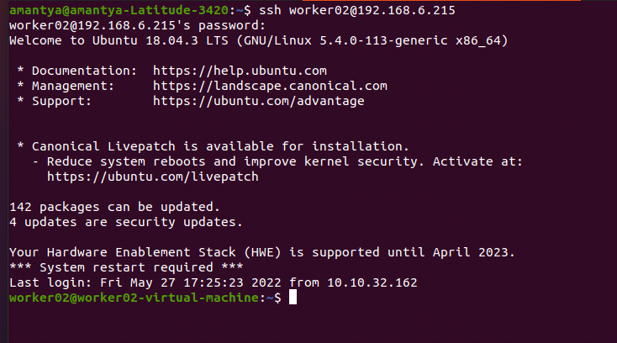
Deployment process
Step1 Get git clone from github
git clone https://github.com/5GRealityLab/do_dashboard_ui.git
Paste on master server then run
Step2 How to build the Docker image for front-end Deployment.
- Got to the path where the Dockerfile is exist , cd /5GRealityLab/do_dashboard_ui/tree/main/hum-verizon-ui
- docker build -t <image name which you want to create> .
- put command , docker images
- 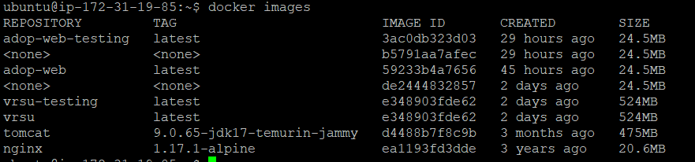
- In above image you find your image name which you build for front-end.
Step3 How to build the Docker image for back-end Deployment.
- Got to the path where the Dockerfile is exist , cd 5GRealityLab/do_dashboard_ui/tree/main/vrsu-subscriber-manager
- docker build -t <image name which you want to create> .
- put command , docker images
- In above image you find your image name which you build for back-end.
Step4 Set a path cd 5GRealityLab/do_dashboard_ui/tree/main/vrsu-helmchart
Step5 changes on values.yaml file repository, tag, node selector and hugepages
- sed -i 's/repository: hum-server-fe' values.yaml for frontend
- sed -i 's/repository: <REPOSITORY_NAME>/vrsu-backend' values.yaml for backend
- sed -i 's/ex = latest/<Tag of the build image mention in docker image>/g' values.yaml
- Changes from this below image.
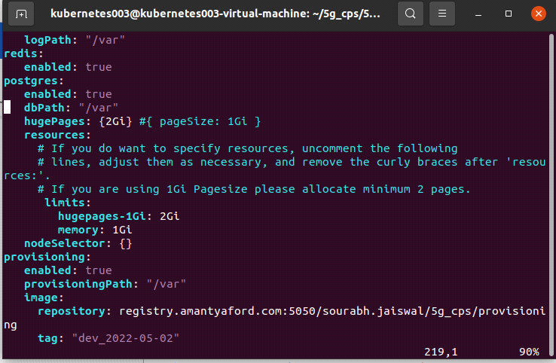
Step6 Install helm follow below steps
- curl https://baltocdn.com/helm/signing.asc | sudo apt-key add -
- sudo apt-get install apt-transport-https –yes
- echo "deb https://baltocdn.com/helm/stable/debian/ all main" | sudo tee /etc/apt/sources.list.d/helm-stable-debian.list
- sudo apt-get update
- sudo apt-get install helm
OR
- curl https://baltocdn.com/helm/signing.asc | gpg --dearmor | sudo tee /usr/share/keyrings/helm.gpg > /dev/null
- sudo apt-get install apt-transport-https –yes
- echo "deb [arch=$(dpkg --print-architecture) signed-by=/usr/share/keyrings/helm.gpg] https://baltocdn.com/helm/stable/debian/ all main" | sudo tee /etc/apt/sources.list.d/helm-stable-debian.list
- sudo apt-get update
- sudo apt-get install helm
Step7 Set a path cd 5GRealityLab/do_dashboard_ui/tree/main/vrsu-helmchart
In below install command you start pods of helm
- helm install vrsufrontend vrsufrontend
- helm install vrsubackend vrsubackend
In below uninstall command you uninstall pods of helm
- helm uninstall vrsufrontend
- helm uninstall vrsubackend
In below upgrade command you upgrade pods of helm
- helm upgrade vrsufrontend vrsufrontend
- helm upgrade vrsubackend vrsubackend
Check your helm pods by Commmand:-
- kubectl get pods
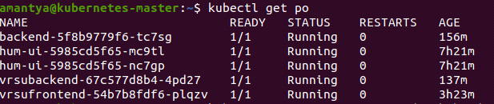
Above image is your result.
Used below Commands
- kubectl get pods –A
- kubectl get po –o wide
- kubectl get no
- kubectl describe po <pod_name>
- kubectl log <pod_name>
- kubectl exec –it <pod_name> bash

